PAPER BARK CANTEEN
BREAKFAST  Toast - Plain or Raisin $1.00  Vegemite $1.00  Muffins $3.50 Bacon & Cheese Rolls $2.50  Up & Go’s $2.00  Poppers $1.50  Hash Brown $0.50  Croissants $2.00  Yogurt & Muesli Cup $2.00  Fruit Cup (All Day, Every Day) $2.00  FRIDAY BREAKFAST ONLY  Bacon & Egg Muffin $2.50  Bacon Muffin $2.00  HOT FOOD  Chicken Fingers x 4 $2.00  Chicken Fingers x 6 $3.00  Chicken Nuggets x 4 (GF) $2.00  Chicken Nuggets x 6 (GF) $3.00  Hot Dogs (GF) $2.50  Noodle Cups Chicken/Beef $2.50  Pizza Rounda $3.50  Sausage Rolls $3.00  Sweet Chilli Chicken  Subs/Wraps $3.00  Plain Chicken Wrap $3.00  Garlic Bread $2.00  Slams - Chicken/Beef $2.50  Pies – Cheese & Bacon, Potato $4.50  Plain Pie $4.00  Snack Pies $2.00  ORDER ONLY  Fried Rice (With bacon) $4.50  Vegetarian Fried Rice $4.00  Gluten Free Sausage Rolls $4.20  Gluten Free Meat Pie $4.50  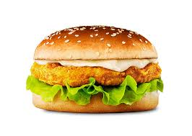  BURGERS  Chicken Burgers $5.00  Hamburger $6.00  Cheese Burger $4.20  Vegie Burger (Lettuce & Tom) $5.00  Spring Rolls 6 for $2.00  3 for $1.00  HOME MADE PIZZA $4.00  Ham & Pineapple, BBQ Chicken  Vegetarian  Tomato/BBQ Sauce $0.40  SPOONS & FORKS $0.10c | DRINKS  500ml Flavoured Milk $3.50  300ml Flavoured Milk $2.50  250ml Flavoured Milk $2.00  Plain Small Milk - Sml $1.50  - Lrg $2.00  Up & Go’s $2.00  Poppers $1.50  Mango & Orange Juice $4.00  Juices - Large $3.50  - Small $2.50  Water - Large $2.00  - Small $1.00  Slushies $2.00  Chips $1.00  Doritos, Cheese/Onion, BBQ $2.00  Vegie Chips $2.00  ICE CREAMS & ICE BLOCKS  Moosies $1.50  Icy Poles – Lemonade $1.20  - Raspberry $1.20  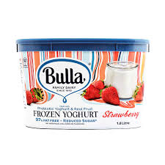  Juices $1.20  Ice Cream Cup $1.20  Frozen Yogurt $2.00  Ice Cups $0.80  Quelch Sticks $0.50  ORDER ONLY  SANDWICHES/ROLLS/WRAPS  Roll/Wrap/Bread (Wholemeal/White) $1.00  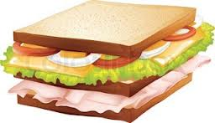  Vegemite $1.20  Cheese $2.20  Egg $2.50  Lean Meat $3.00  (Chicken, Ham, Tuna & Salmon)  Salad $4.00  (Tomato, Cheese, Lettuce, Carrot & Cucumber)  Extras  Add to sandwich, roll or wrap price  Salad $2.00  Lettuce, tomato, cucumber, & carrot  Each Item - Cucumber, Lettuce, Egg  Tomato, Beetroot, Cheese, Carrot $0.50  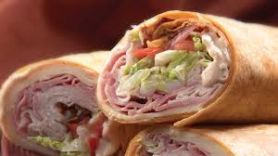  WRAPS  Salad $5.00  Salad & Meat $6.00  SALAD BOX $5.50  SALAD BOX with $6.50  (Meat/Tuna/Salmon/Egg) | CANTEEN HOURS  Monday – Friday Breakfast  7.30am – 8.20am  Mon, Tue, Wed & Friday  First Lunch – 10.40am-11.05am  Second Lunch 1.10pm-1.35pm  Thursday Only  First Lunch - 10.40am – 11.05am  Second Lunch 12.10pm – 12.35pm  SPECIAL DAYS  TUESDAY  SUSHI  TERIYAKI CHICKEN  VEGETARIAN  CRISPY CHICKEN  $4.00  (Freshly Made)  WEDNESDAY  BUTTER CHICKEN  & RICE  $5.00  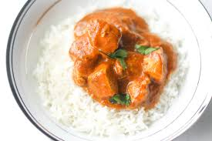  FRIDAY  NACHOS  $5.00  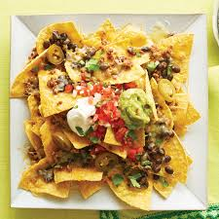  EFPOS AVAILABLE

