Taronga ZoosnooZ
Participant Information

We try to make ZoosnooZ as easy as possible for our guests.
The information here outlines the most common aspects of the program.

Please ensure all participants read this information

Adult Participants (Teachers and Parent Helpers)
It is the school’s responsibility to select appropriate adults with an updated Working with Children Check and who are equipped to be active supervisors of the group.

- TEACHER: PARENT RATIO: There must be equal or MORE teachers in attendance. This is a minimum we have chosen to ensure adults are active in supervision and that students benefit from the school event.
- It is the school’s responsibility to ensure "Working with Children Check" is satisfied according to NSW Legislation. Duty of Care for all participating students and staff is the responsibility of the organising school.
- Active supervision enables our staff to focus on the program and deliver the best possible experience for your students. Teachers and extra adults are required to actively supervise students at all times, helping with group management, punctuality and general arrangements.
- The Adult role on ZoosnooZ is to actively supervise your students. Your proactive supervision is an important element to a fantastic program.
- Sleeping Areas: There are a number of areas for group sleepovers. According to your group size, the most appropriate sleeping area will be chosen for your group at the time of the booking. It is not always possible for us to change the venue of your accommodation after the booking is made. Changes in student numbers may also change your accommodation venue. Significant changes in student numbers may not be able to be accommodated after your booking, due to other bookings on the same night.
- Equipment: Taronga Zoo provides a stretcher and a camping mat for adults. Adults should bring their own sleeping bag and pillow. Spare bedding is not provided.
- Sleeping location: Adults are required to supervise students at all times, including during the night. Adults sleep in the same location as the students. Please ensure all adult participants are aware of this arrangement and have appropriate evening wear.
- Sleeping Areas should be left clean in the morning. Adults are expected to instruct students to clean up ‘after themselves’ and ensure that this occurs.
- Amenities: Male/Female toilets are within easy access of all areas through the program. There are no shower facilities available, even for adults and or zoo staff. Participants should bring their own personal toiletries etc.
- Animals are housed in some of the sleeping areas. We can usually accommodate people with certain phobias and in this case, we ask that you make your concerns known at the time of booking and to our hosts on the night.

General information for Students
Please distribute this information to students and parents to prepare for the visit.

  - Students are to behave in an appropriate manner, showing respect to teachers, adult supervisors and all Zoo staff.
  - Students are expected to follow instructions from all adults including teachers, adult supervisors and the wider Zoo staff.
  - Sleeping location: Students are located in rooms or permanent tents. According to the school’s group size, the most appropriate sleeping area has been chosen for your group at the time of the booking.
  - Equipment: Taronga Zoo provides a camping mat. Students should bring their own sleeping bag and pillow. Spare bedding will not be provided.
  - Students are to remain in these sleeping areas through the night as per the instructions from Zoo staff members.
  - Students are to leave the sleeping areas clean in the morning.
  - Amenities: Male/Female toilets are within easy access of all areas through the program. There are no shower facilities available. Participants should bring their own personal toiletries etc.
  - Animals are housed in some of the sleeping areas. We can usually accommodate people with certain phobias and in this case, we ask that you make your concerns known to the school and to our hosts on the night.

Students should bring:
  - Day 1: sleeping bag, pillow, toothbrush/toiletries, pyjamas, weather appropriate clothing (we will walk around the zoo at night time). ZoosnooZ is an all weather program and students are expected to bring appropriate wear such as rain coats, warm layers etc.

  - Day 2: A day pack with water bottle, hat, sunscreen, camera, *meals as directed by the school

Please Note: The size of student luggage for ZoosnooZ should be the equivalent of small back pack or carry-on luggage for plane travel. Larger suitcases cannot be stored.

Program start and finish times and Arrival.
The ZoosnooZ program commences at 5.15pm and finishes at 9.00am the following morning. There is no entry to ZoosnooZ or Taronga Zoo prior to 5:15pm on the night of your booking. Entry to Taronga Zoo is included in your ZoosnooZ booking for the following day only.
Please text your ZoosnooZ Hosts on approach to the Zoo so they can meet you. ZoosnooZ Host Mobile: 0449 901 920. This phone is in use from 5pm on the day of your visit.

For security reasons, students will not be able to leave the program early unless in the case of an emergency. All students attending are required to stay for the duration of the program including the overnight component. Any students who are unable to stay overnight but wish to meet their school the next day, will need meet them at the end of the ZoosnooZ program at 9am at the main Zoo entrance. Next day rendezvous must be organised with your school in advance.

Meeting Place:
All coaches will be met by ZoosnooZ staff at 5:15 at the Coach Parking on Bradley’s Head Road. Please note this is a new location for coach parking.

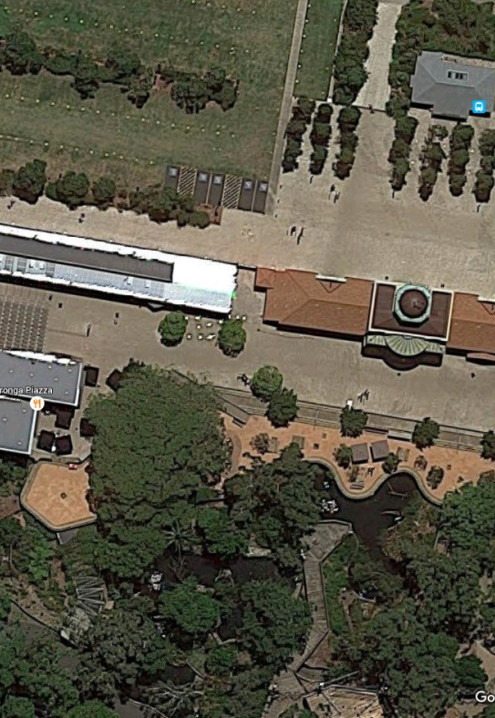
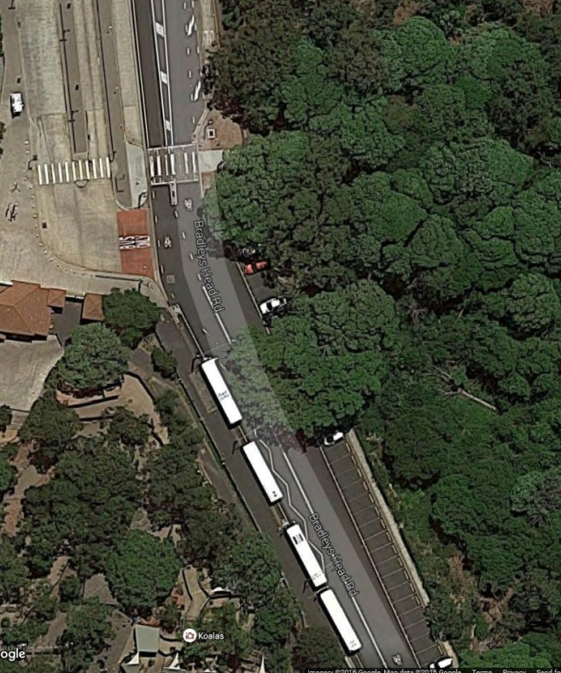
COACH PARKING -
Zoo Entrance
New Location for ZoosnooZ Drop Off

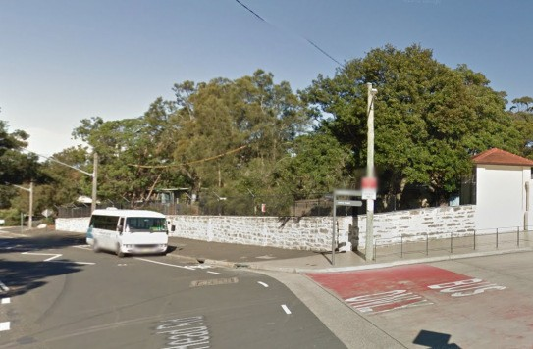
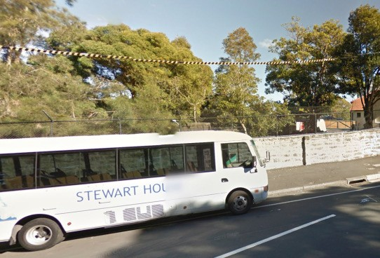
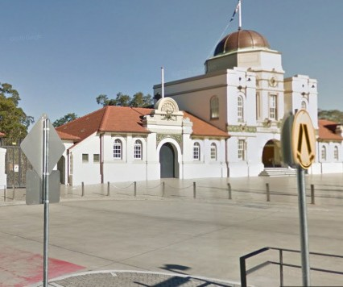
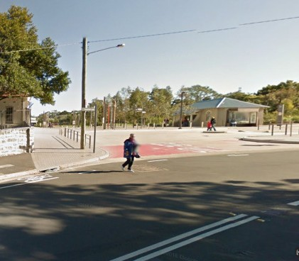
All coaches will be met by ZoosnooZ staff at 5:15 at the Coach Parking on Bradley’s Head Road.

Please note your hosts will be unable to meet you prior to 5:15pm. Entry to the zoo prior to this time is not permitted.

Teacher and Parent numbers and participation:
Teacher student ratio is based on the accommodation option booked by your school. A minimum of 2 teachers per booking is required; however more teachers/supervising adults are permitted for primary aged and special needs students.

Teachers and extra adults are required to actively supervise students at all times, helping with group management, punctuality and general arrangements. As a condition of entry, it is expected that all teachers and supervisors follow the directions of all Zoo staff at any time during your visit, including next day entry. Participating in additional tasks, such as meal serving and learning activities is strongly encouraged as a way for you to enjoy the sleepover too. Close supervision through the program helps to ensure you and your group can maximise all of the experiences Taronga has to offer.

Please advise your parent helpers that they are there as supporting staff for ALL students on the excursion, and are expected to adhere to the same responsibilities and conditions of entry as teaching staff. It is the school’s responsibility that all attending adults have relevant Working with Children Checks.

Overnight supervision: Between 10.00pm and 6.00am (wake up time), teachers and extra adults are the primary source of supervision. Taronga Staff are available overnight in an emergency situation. Our hosts sleep close to your group and are fully contactable. Zoo Security is also on site 24 hours a day. Should you require assistance (for example, sick student) our staff are ready to help with whatever you require.

Special dietary requirements.
While we endeavour to cater for allergies we are unable to guarantee a nut/allergy free environment. We encourage all those with severe allergies to provide their own food (refrigeration can be provided) and bring medical action plans as necessary.
If you have any special dietary requirements (gluten intolerance, vegetarian etc) the organising teacher must email our office at least two weeks prior to your excursion so that we can cater for your needs. Last minute dietary or medical requirements cannot be provided on the night of your visit.

Sleeping arrangements/Locations.
Your ZoosnooZ will be held in one of our ZoosnooZ sleeping venues.
Tents: Boys and Girls are to sleep in separate tents. Supervising teachers and adults are required to sleep in tents within the vicinity of students. Please ensure all attending teachers are aware of this arrangement. All students must be adequately supervised throughout the program. Adult supervisors are NOT permitted to share a tent with any students.

B2B House: Supervising teachers and adults are required to sleep in the rooms with the students. Please ensure all attending teachers are aware of this arrangement. As per the Department of Education and community policy, we do not distinguish between the gender of adult supervisors. All students must be adequately supervised throughout the program. Adding to the adventure - some of the rooms do contain animal enclosures!

Male and female toilets are located a short walk from all venues. The toilets will be open all night.

Other schools or groups
Please be aware that you school may not be the only group attending ZoosnooZ on the same night. Whilst all efforts are made to ensure minimal contact between schools, please note you may not have the site to yourselves. Meals, animal encounters, walks and Meet a Keeper experiences are all conducted exclusively with your student group.

Shower facilities.
Unfortunately there are no shower facilities available for teachers or students.

Sick or ill students.
Wherever possible, sick or ill students should be asked to refrain from attending for the health and safety of all students, school and Zoo staff and our animals.
Should a situation arise whereby a student is sick, eg vomits, our staff must be notified so we can ensure proper hygiene practise is maintained and emergency clothing, bedding, towels etc are provided for the ill child.
Please always tell us so that we can help to care for the student and make the best of an unfortunate situation. Students who are severely ill may need to be collected from the program early.

Equipment
Pack light! You will need to bring toiletries, a sleeping bag and a pillow. We will provide a self inflating camping mat. Wear comfortable walking shoes, and bring warm clothes/raincoat if the weather looks grey. Our beautiful harbour location can mean we are exposed to the elements, particularly cool winds of an evening.

Alcohol is Prohibited
Taronga Zoo is a strictly no alcohol event. No alcohol is supplied for teachers/parents and no BYO alcohol is permitted on the ZoosnooZ program at Taronga.

What animals will we experience at our Meet a Keeper Experiences?
The Meet a Keeper experience at Taronga varies depending on the availability of animals and the keepers who care for them. All Meet a Keeper Experiences are confirmed on the morning of your stay and can include experiences such as our Tasmanian Devil breeding facility, Backyard 2 Bush Farmyard, Nocturnal House keeper kitchen or ‘Free flight’ Bird Show.

First aid certification
All teachers need to have a current first aid awareness. It is advisable to bring at least one teacher/adult supervisor with a current senior first aid certificate. Teachers and parents are responsible for the administration of first aid in the event of an emergency. Zoo staff must be informed of any incident requiring first aid. A compulsory safety briefing given by your hosts will occur at the commencement of the evening. Our hosts are available in the event of an emergency to assist with Taronga emergency procedures such as evacuations.

Luggage after ZoosnooZ.
The ZoosnooZ program officially finishes at 9am, when you are welcome to enjoy the zoo at your leisure. Your luggage will be stored near the top entrance of the Zoo while you explore the Zoo during the day. Taronga staff will inform you of the procedure for the collection of your luggage.
Please note: upon arrival and departure to the zoo the students will be required to transport their own luggage as directed. Taronga Staff will not unload and load luggage from a coach. Do not arrange for your coach driver to arrive independently to deliver baggage. Baggage must arrive with the students at the program start time of 5:15pm. Luggage storage before the program start time is not available.

Special needs students and special needs groups.
We welcome special need students and groups. Please feel free to contact our office to discuss your group’s individual needs and we will do our best to accommodate you. Email education@zoo.nsw.gov.au to discuss your needs.

Site accessibility
While there are wheelchair friendly and accessible paths available across the zoo, the ZoosnooZ program does require adequate mobility to navigate the zoos steep hills and narrow pathways especially in the dark. While consideration can be made for students with mobility issues, it is advised that all supervising teachers and adults have full mobility and adequate physical fitness. Students or teachers are unable to be left on site unattended while the group participates in walks and Meet a Keeper experience. Please contact education@zoo.nsw.gov.au for more information and to advise of any special needs.

Sky Safari (cable car) is not included.
Students are not permitted on the Sky Safari Cable Car when attending the ZoosnooZ Program.

Our class is studying a special topic – can you help with this?
Our ZoosnooZ staff cannot teach curriculum focused lessons as part of the ZoosnooZ overnight program. The program includes animal meet & greets where our hosts introduce special animal ambassadors and their unique features and habitats.
If you are interested in curriculum focused lessons, next day workshop options are available with a qualified Zoo teacher and cost
$6/student. The scheduled times for these workshops are 10:30am, 11:30am and 12:30pm. For workshop options please visit https://taronga.org.au/education/sydney/workshops Workshops are to be requested when sending the completed ZoosnooZ Contract via email education@zoo.nsw.gov.au (Next day workshops are subject to availability)

Here is a sample programme for the night and following morning.
5.15pm: Arrive at Taronga Zoo; meet your hosts, set down luggage, walk to accommodation location
6:00pm: Formal intro, orientation and icebreakers. A mandatory work, health safety briefing for teachers will occur during this time.
6:30pm: BBQ Dinner (which includes sausages, pasta, salad and drinks) Reminder: to cater for special dietary requirements we require 2 weeks notice. 7.00pm: Animal encounters – look, touch and ask questions!
7:45pm: Night Safari walking tour – see the zoo after dark
9:00pm: Fruit supper and set up for bed
9:30pm: Lights Out

6:00am: Rise and Shine
6:30am: Breakfast time (toast, cereal and juice)
7:00am: Animal encounters – look, touch and ask questions!
8:00am: A special ‘Meet a Keeper’ experience
8:30am: Morning walk to see the Zoo waking up
9:00am: Program finish time, you will be dropped at the main entrance of the zoo for some free time before the zoo officially opens the gates at 9:30am. If you have a next day workshop booked please check with your hosts where to meet your zoo teacher.

This is a guideline only, as times may vary without notice.

Lunches for the following day.
Next day lunches can ONLY be PRE-ORDERED directly with our catering company. Please contact:
Restaurant Associates
Taronga Centre Restaurant Associates Australia Tel: 9969 2400
tarongareception@restaurantassociates.com.au

This is booked separately to your ZoosnooZ, Taronga Reception will advise of the location to pick up your lunches. For more information, including payment, please contact them directly.

Extra Children/Students
Duty of care requirements and insurance limitations determine that children who are not students cannot attend the ZoosnooZ. There is also a strict 5year + age requirement for all participants.
Numbers must be finalised two weeks before your ZoosnooZ, minimum and maximum student numbers must be adhered to. Large changes to student numbers may not be accommodated.

Contact details:
Please feel free to contact us with any further questions or to discuss your schools needs. Phone: (+61) 02 9978 4624 or 9978 4578
Email: education@zoo.nsw.gov.au
When contacting the Zoo via email
Email Subject: Your School Name & Date of Visit for ZoosnooZ

