Healthy and Eco-friendly
Party Craft Workshop

Get ready for the next party! Grab the kids, Grandma or your best mate and come along to learn about the 3 R’s and how to be resourceful by creating some healthy party bags, greeting cards or gift bags. They will be made from recycled and mostly recyclable materials. Ages 5 and up welcome.
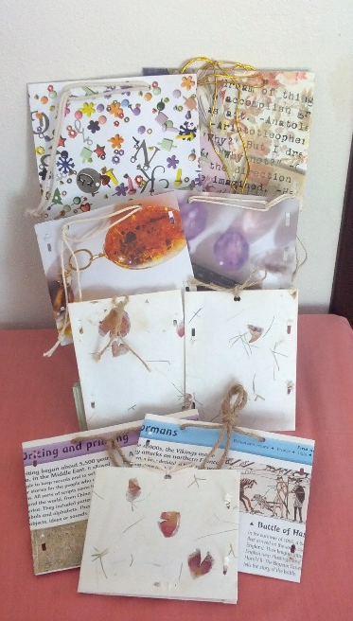
Party bag goodies include:
- Packet of vegetable seeds to plant
- Jokes
- Puzzle (crossword or find-a-word)

Party goodies will provide great inspiration for those picky eaters to learn a bit about those foods you would love them to eat.

Date: Thursday 20th July
Time: 10am- 11am
Address: Peninsula Community Centre, 93 McMasters Rd, Woy Woy
Cost: $10 per person or $5 per party bag created (minimum 2)
The future is swapping! Bring materials to share and exchange for pre-made cards, party bags or gift bags. Bring along any used cardboard/paper shopping bags, cardboard (eg tissue boxes), ribbons, string, rubber bands, wrapping paper, spare pages ripped out of an old exercise book, old comic or story books, colouring in books and anything else you can think of that could be upcycled in a craft project.
Book your place by calling Carin on 0407 492 278 or email brightdiets@gmail.com.
If you are interested in attending but the time and date does not suit, please get in contact so future groups can run at a suitable time for you.

Feel happy, healthy and vibrant.

Bright Diets is run by Carin Clegg, Accredited Practising Dietitian and Personal Trainer.

I understand the challenges people face regarding the role of food and their health. Often there is no one diet fits all approach or one therapy fits all approach and that making changes is actually quite difficult.

Specializing in food allergies, food intolerances, intellectual disability (such as ADHD, ASD), paediatrics, fussy eating, weight management, diabetes, heart health IBS and much more, I can help you and your family understand the role of diet in your life and find the right diet you need to feel bright in every sense of the word.

Consults
60 minute (initial) $100
90 minute (initial complex -food intolerance, family) $150
30 minute follow up $52.95
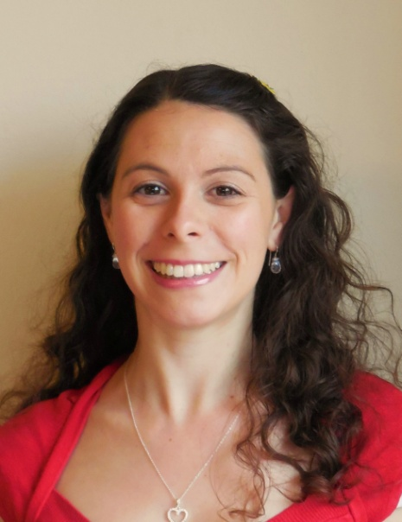
Home visits also available.

Rebates are available through Medicare and private health insurance companies.

Educational Cooking Classes
Healthy Eating for Parents and Children
Fussy Eating for Parents and Children

Nutrition talks
Food Allergy and Intolerance
Eating for Optimal Health
Secrets to Staying in Shape
Combat Fussy Eating
Diets for ADHD and ASD

Understand the role diet plays in your health and achieve your health goals by booking your Dietitian consultation today on 0407 492 278.

Visit www.brightdiets.com.au for information about various services and packages.

