Food Allergy or Intolerance?

If you are concerned you or someone you know has food related complaints, can’t tolerate gluten or dairy, or merely suspects food plays a role in various symptoms, then come along to this talk.
- Discover what the differences are between Food allergy, Food Intolerance including lactose intolerance, Irritable Bowel Syndrome, the role of FODMAPS and Coeliac Disease.
- Find the right path you need to follow to finally get back in control of your symptoms.

Run by Carin Clegg, specialist Food Intolerance Dietitian.
Date: Thursday 29th June
Time: 4pm-5pm
Address: Peninsula Community Centre
93 McMasters Rd, Woy Woy
Cost: $10 per person

Book your place by contacting Carin on 0407 492 278 or email brightdiets@gmail.com

If you are interested but can not make it, please let me know your preference so I can run the talk again at a more suitable time.

Feel happy, healthy and vibrant.
Bright Diets is a Dietetic and Fitness practice run by Carin Clegg, Accredited Practising Dietitian and Personal Trainer.

I understand the challenges people face regarding the role of food and their health. Often there is no one diet fits all approach or one therapy fits all approach and that making changes is actually quite difficult.

Specializing in food allergies, food intolerances, intellectual disability (such as ADHD, ASD), paediatrics, fussy eating, weight management, diabetes, heart health IBS and much more, I can help you and your family understand the role of diet in your life and find the right diet you need to feel bright in every sense of the word.

Dietitian Consults
- Wyong Family Practice
- Wyong Village Medical Centre
- Woy Woy General Practice
- Caligem Health, Gosford

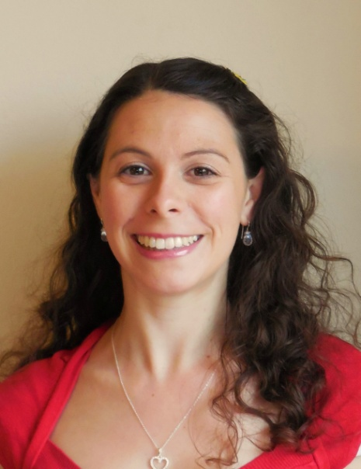
Home visits also available for those with difficulty coming into clinic.

Rebates are available through Medicare and private health insurance companies. DVA and NDIS provider.

Educational Cooking Classes
-Healthy Eating for Parents and Children
-Fussy Eating for Parents and Children

Nutrition talks available on request
- Eating for Optimal Health
- Staying in Shape with Good Nutrition
- Food Allergy and Intolerance
- Combat Fussy Eating
- Diets for ADHD and ASD

Understand the role diet and exercise plays in your health, learn how to make sustainable changes and achieve your health goals by booking your appointment today on 0407 492 278.

Visit www.brightdiets.com.au for information about various services and packages.

